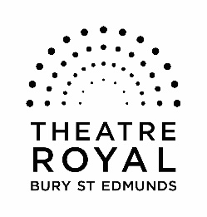

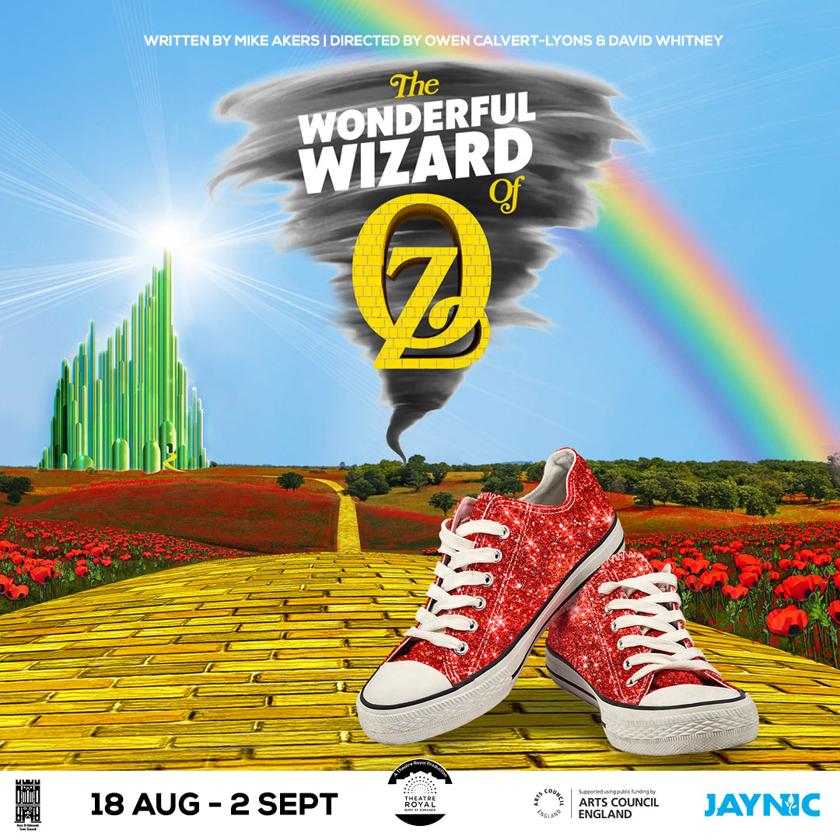

EASY READ AND VISUAL STORY

The Wonderful Wizard of Oz
Adapted by Mike Akers

A Theatre Royal, Bury St Edmunds Production

This is a full synopsis of the show with matching photographs and details for anyone who may benefit from knowing the story and details ahead of time.
Please note that this guide will contain spoilers.

Content Warning

The show will contain loud bangs in the form of thunderclaps, some use of pyrotechnics’ and smoke jets.
The scenes in which these happen will be clearly identified within this pack.
We do have a small stock of ear-defenders available for those who would like to use them.
There will also be moments of bright dazzling lights.

Please also note:
Throughout the show, several members of the cast will be playing more than one role.
The roles of each of our company are labelled clearly next to their name within this pack.
There will also be moments of voice over.
The show is captioned.
A captioning device will sit on the right-hand side of the stage as you look at it. This will display the spoken words of the actors.

Trigger Warnings:
Death
Animal Cruelty
Mentions of Illness

Performance Times
The show is expected to last around 2 hours and 10 minutes including the interval.
Act One: 55 minutes
Act Two: 49 minutes

Cast

Professional Cast
Darcy Manning – Dorothy
Ronan Quniou – Toto
Daniel Walford – Tinman
Nicola Bryan – Aunt Em/ West Witch
Michael Lambourne – Uncle Henry/Oz

Community Company
Andi Dodds – Mum/ North Witch
Wendy Hamilton – Guard
Eloise Probitts – Lion
Jasmine Briggs – Scarecrow and Weatherperson

Young Company
(Playing Munchkins, Flying Monkey’s and Courtiers)

Rainbows
Poppy Warton
Rowan Kimber
Jaiya Rai
Kaylin Hardy
Seth Jackson
Emily Reeves

Tornados
Heidi Lambourne
Jack Ramplin
Charlie Negus
Khloe Sheppard
Eden Francis
Liana Lashley

Production Team

Directors – Owen Calvert Lyons and David Whitney
Producer – Zoe Fox
Designer – Morgan Brind
Composer and Musical Director – David Lewington
Choreographer and Movement Director – Sundeep Saini
Lighting Designer – Dave Thwaites
Sound Designer – Chris Last
Wardrobe Supervisor – Rebecca Rawlinson
Wardrobe Assistant – Corrine Beaumont
Photography – Neil Baxter Photography
Videography – Dan Cole Media
Summer School Co-ordinator – Emma Thorpe
Captioner – Grace Evans
Revolve Operator – Michael Ackland-Lang
Lighting Operator – Kate ‘Sky’ Skylar
ASM – Shay McCourt
Production Manager – Andy Stubbs
DSM – Becky Brown

Characters

The show is set in Stowmarket in present England before moving to the land of Oz and the Emerald City.
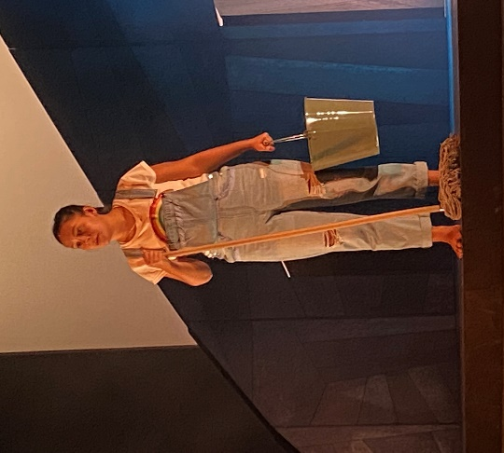
Dorothy
Our main character. A strong young woman who carries the weight of the world on her shoulders. All she wants is for her mum to get better and come home. She fights for what she wants and leads her friends on a great adventure.

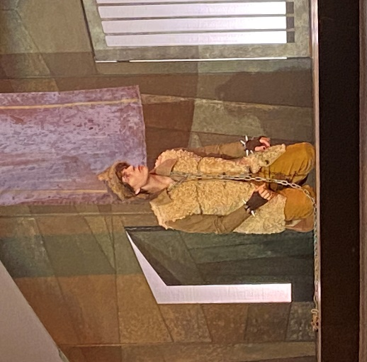

Toto
Dorothy’s beloved dog and our narrator. Speaks multiple languages. A fun, playful character with lots of personality.

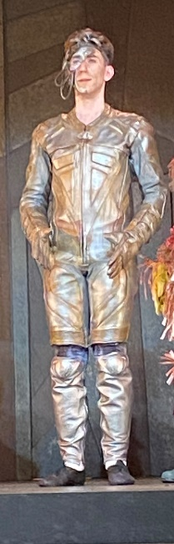

Tinman
Desperate for a heart. A charming and thoughtful character who loves to dance.

Scarecrow
At only one day old, the Scarecrow is a little ditzy. The farmer made them “with an empty head” and so Scarecrow thinks they need to find some brains in order to be a good Scarecrow. Through Scarecrow’s innocence, they are a funny, inquisitive character unsure of who and what things are around them.

Lion
At the start of the play, the Lion is shy and fearful, described by others as cowardly. They have started to doubt themselves, often brought to tears in Act 1. But they have a big heart and, through wanting the best for their friends, finds their courage

Wicked Witch of the West
The Wicked Witch is an arch villain. She is fabulously evil and a formidable character.

Aunt Em – Due to Dorothy’s mum (Em’s sister) being unwell, Aunt Em is taking care of her niece. She feels ill-prepared for looking after a child and takes an authoritarian approach.

Uncle Henry - Uncle Henry is calm and loving, but struggles to make his voice heard and will always take his wife’s side in an argument

Wizard of Oz - Oz is a great and powerful wizard.

Mum - Dorothy’s mother. A warm, kind character who loves Dorothy dearly. There is a slightly mystical side to this role as there is an ambiguity around whether she has, or hasn’t been to Oz.
When we first meet mum, she is being seen at the hospital. We learn here that is ill.

North Witch - Sister of the Wicked Witch of the West. An eccentric, friendly character who introduces Dorothy to Oz and gives a flavour of this upside-down new world

Other Characters include:
Medic
Weatherperson
Newsreader
The Guard
Flying Monkeys
Courtiers
Munchkins

Musical Numbers

There is no place like home
Introducing Oz
Team up Toto
Emerald City
Perfect
Finale

Set

The area at the top is where some elements of the set will ‘fly’ into the performance space.
Within the land of Oz, you will see the doors to Oz’s chamber, a banner which the flying monkeys will pull down, alongside lighting fixtures.
Here is a trap door.
This will open up during Lion’s entrance in A1 S13.

Built into the back of the set are two doors. These will open throughout the show allowing for the actors to enter and exit the stage.

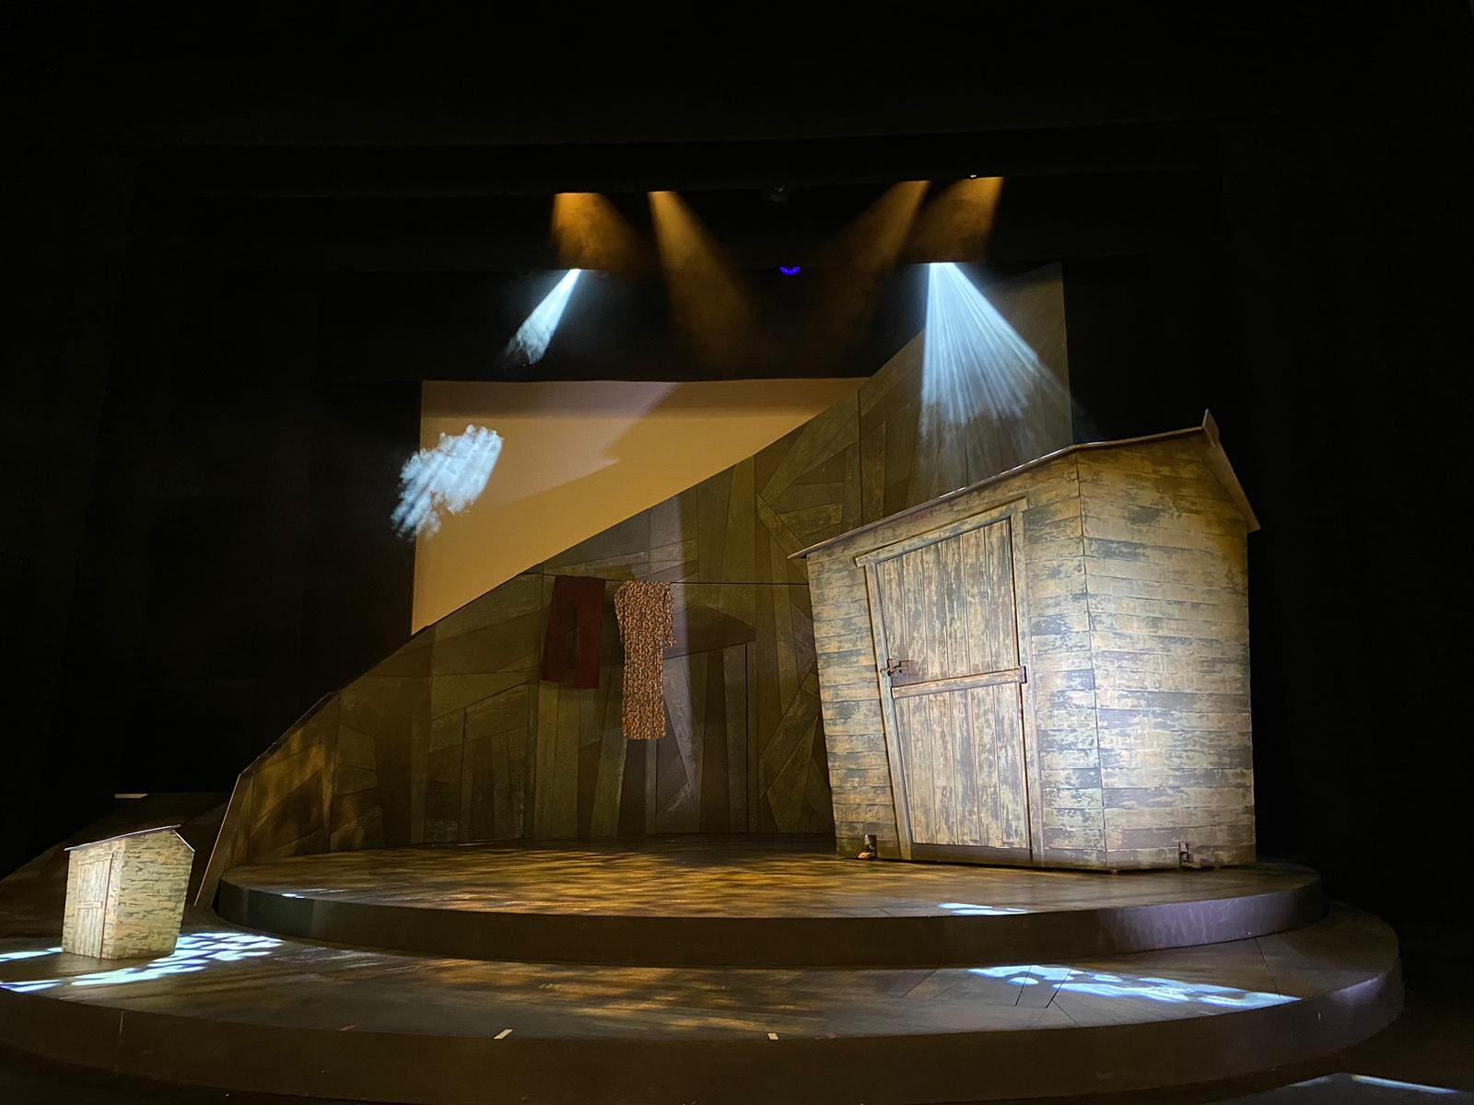

During A2 (Scene 21), a pyrotechnic will go off from this position. It will feature a short, bright light with a loud bang. A trail of smoke will follow.
Our main performance area is on a technical piece of staging equipment called a revolve.
This will turn in a circular motion. It can move set pieces and actors around the stage in a clockwise and anticlockwise direction.

Key:
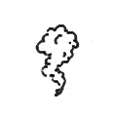
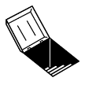
Bright Lights
Trapdoor
Song
Loud Noise
Smoke Jet
Pyrotechnic

Act One

Scene One - Toto introduces Dorothy to the audience.

Scene Two – Dorothy and Toto arrive at Aunt Em and Uncle Henry’s house.

Scene Three - Toto introduces himself to the audience.
Scene three into four – Loud clocks and chimes

Scene Four - Dorothy is talking to the medic about her mum. This scene is set in a hospital.

Scene Five - Aunt Em and Uncle Henry discuss Dorothy living in the shed with Toto.

Scene Six – A flashback scene where Mum gifts Toto to Dorothy.

Scene Seven -Dorothy transforms the shed into a home. Aunt Em suggests Dorothy sleeps in the house without Toto. Dorothy declines.
Song: There is no place like home

Scene Eight - A cyclone hits the garden shed.
During the Cyclone – loud wind and crashing shed sounds

Scene Nine - Dorothy and Toto land in Oz. They are greeted by the munchkins who celebrate her for killing the Witch of the East. The North Witch shows Dorothy around.
Song: Introducing Oz
Deep rumble/ boom when North West mentions the Wizard of Oz
Yellow Brick Road dance
Lion roar throughout

Scene Ten - The Tinman, Scarecrow, Lion, Toto and Dorothy arrive at the gates of city of Emeralds. This scene is a flashback.
Emerald City doorbell and gates opening
Clocks and chimes throughout transition

Scene Eleven – Dorothy and Toto meet the scarecrow.
Yellow Brick Road dance

Scene Twelve – Dorothy, Toto and the Scarecrow meet the Tinman.
Tinman Dance

Scene Thirteen - Dorothy, Toto, Scarecrow, and Tinman meet the Lion.
Lion appears from a trap door
Song: Team Up Toto

Scene Fourteen - The gang arrive at the gates of the Emerald City.
Scream
Bright red light – “As I mentioned, it was a long and severely testing journey to the Emerald city” - Toto
Bright dazzling lights before the interval
Emerald City doorbell and gates sounds
Interval music

Act Two

Scene Fifteen - Dorothy enters the palace of Oz. She speaks to the courtiers before being presented to the Wizard of Oz.
Song: Emerald City
Guard knocks on the throne door
Wizard’s Voice

Scene Sixteen - Dorothy and Oz talk in the throne room.
Wizard’s Voice
Booms on “How Dare you” – Wizard of Oz
(Previous line: I want to find my way home. Please can you show me the way? – Dorothy)

Scene Seventeen - Dorothy and the gang decide to find the Wicked Witch of the West.

Scene Eighteen - Dorothy and the gang start off on their journey. Dorothy believes she sees the medic and heads towards them. The rest of the gang are attacked by flying monkeys.
Monkey attack music

Scene Nineteen - Dorothy and the West Witch talk.
Thunderclap on Wicked Witch of the West entrance

Scene Twenty - The West Witch forces Dorothy to clean the room they are in. Dorothy goes outside and finds Toto and Lion chained. Dorothy releases Lion and he goes to save the Tinman and Scarecrow who are still in the desert.
Song: Perfect
Thunderclap at the end of the song
Twinkle sound when Dorothy passes the kiss to Lion on forehead
“Zizzy Zazzy Zozzy Zeek, every language you can speak – West Witch”.
Previous line: “Why is Dorothy singing such a jolly song? Why is she happy? I command you to tell me!” – Wicked Witch of the West
Four spells cast on Toto by the Witched Witch of the West

Scene Twenty – One - Scarecrow, Lion, and Tinman fight the flying monkeys through dance. The Tinman wins. Dorothy throws water over the Wicked Witch of the West causing her to melt. The gang decide to go back to see the Wizard to tell him the news. The gang realise that Toto can speak English.
Dance battle
Wicked Witch of the Witch melts
Smoke jets when the Wicked Witch melts
Short section of the Yellow Brick Road music
Bright dazzling lights facing towards audience

Scene Twenty – Two - Dorothy and the gang arrive back in the city of Emeralds to talk to the Wizard. They learn he isn’t who he says he is. Dorothy makes her way home with Toto.
Wizard’s voice
Lion roars at the wizard

Scene Twenty- Three - Dorothy goes to the hospital to collect her mum.
Song: Finale and Curtain Call

