Youth Advisory Board
Application Pack

- Welcome and information on how to apply
- Role Description
- Application Form
- Theatre Royal in Brief

Youth Advisory Board at Theatre Royal Bury St Edmunds

Thank you for your interest in joining the team at Theatre Royal. Please find enclosed information about the Board and Theatre Royal which I hope will encourage you to apply to join us. Further information about the Theatre can be found on our website: www.theatreroyal.org

If you would like to be considered for this programme, please complete and return the application form and accompanying paperwork by midday on 30 June 2023. interviews will take place w/c 10 July 2023.

Applications will be accepted by email to jobs@theatreroyal.org or by post.

Please address your application to

Central Services, Theatre Royal, Westgate Street,
Bury St Edmunds, Suffolk, IP33 1QR

Good luck and thank you for your interest in working at Theatre Royal.

Yours Sincerely

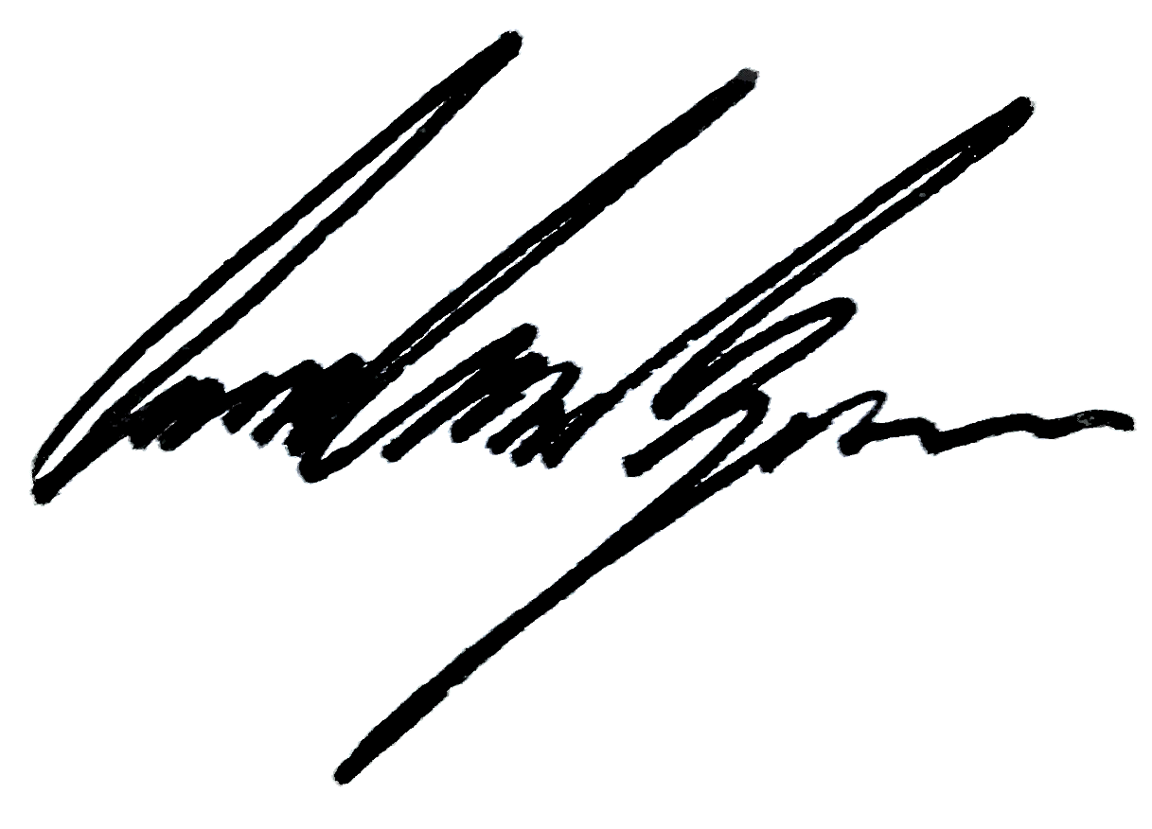

Owen Calvert Lyons
Artistic Director

Youth Advisory Board

Young People and the community are at the core of the Theatre Royal, Bury St Edmunds. Through working annually with 9000 young people, the Theatre Royal aims to make theatre and the arts as accessible as possible to young people within West Suffolk. Through our creative learning projects, Youth Theatre, SENsory Youth Theatre, After School Drama programmes and in-house productions, we want to make sure that young people are not just heard by our core team of staff but also actively represented and seen within our strategic conversations.

Working separately from the main board, the Youth Advisory Board will be facilitated by young people aged between 10-22 years working with the theatre’s core team of staff to reflect the wants and needs of local young people.
The Youth Advisory Board will collaborate on a series of projects chosen by them and by our core team throughout the year, highlighting opportunities for change within our Theatre. The Youth Advisory Board will work together to make sure that young people’s voices are represented within the decisions made at the Theatre and will help generate new ideas to make sure that the Theatre continually represents all of its audiences.
Meeting on the first Tuesday of the month, the board will be made of 8 members who will be led by a Chair of the Board and a Vice Chair working together on projects that will impact both the organisation and the involvement of young people within the building.

Responsible to the Creative Learning Department:

Main Duties

- Attend Youth Advisory Board meetings once a month to discuss ideas, collaborate with other board members and influence decision making.
- Work on events designed to promote youth voice.
- Support the core team in creating social events for young people.
- Collaborating on a series of projects designed to bring improvement and change to the Theatre Royal.
- Acting as ambassadors for Theatre Royal, Bury St Edmunds.

These duties must at all times be carried out with due regard to Theatre Royal’s Equal Opportunities and Child Protection Policies.

Terms & Conditions

This is a voluntary, unpaid position. There is no payment or expectation of payment unless you are asked to do an exceptional paid role -

Volunteers are an essential, unique and invaluable part of running the Theatre effectively, complementing and supporting the work of employed staff.

Theatre Royal does not seek to establish any form of legal contract with individuals, as volunteering is binding in honour only; the relationship is not intended to be legally binding.

You will be expected to volunteer at least 2 hours on the first Tuesday of the month.

Volunteers are asked to:

- Observe our policies, procedures and rules as they apply to the activity for which they volunteer.
- Familiarise themselves with the policies and procedures, especially those relating to Health and Safety.
- Familiarise themselves with the work of the Theatre and our artistic, social and organisational vision, aims and objectives.
- Be willing to undertake appropriate training including customer care training.
- Show respect for fellow volunteers, employees and customers.
- Be reliable and punctual and honour any commitment made to the best of your ability.
- Carry out your voluntary work as outlined in the agreed description or written guidelines and be prepared to be flexible.
-- Recognise our right to expect quality of service from all our volunteers.
- Recognise that they represent us and act appropriately at all times and avoid any word or deed that will bring us or our work into disrepute.

Person Specification

Essential
- A passion for theatre.
- A want to create change.
- The ability to work as part of a team as well as under own initiative.
- Good communication skills.
- Commitment.
Please read the documents which accompany this form before completing your application.

Once completed, please return the form to jobs@theatreroyal.org.

Role Applied for

1 Personal Details

Surname
Forename(s)
Address

Mobile
Landline
Email address
Date of Birth

Name of school

If under 18 (parent or guardian to complete details below
Name of guardian /parent
Contact telephone number
Email address

What change would you like to see at the Theatre Royal, Bury St Edmunds?

In 300 words or less, write a paragraph on one aspect of the Theatre Royal, Bury St Edmunds you would like to see change?

You might want to think about:

- Front of House – Stewards, Items you can buy at the Bar
- Box office – Tickets prices
- Marketing – How we advertise our shows, where you can find out about our shows, our website, our social media content
- Creative Learning – Schools projects, Youth Theatre, SENsory Youth Theatre, After School Drama, Youth Theatre Presents
- Producing – In house productions, how you can get involved
- Programming – What we show on our stage?
- Our Building – Sustainability, Accessibility, Diversity

Tell us about yourself - What makes you a good candidate for our Youth Advisory Board?
Please answer in less than 300 words

.

Signed by the applicant
Date

If under 18 – parent or guardian to also sign

Signature of parent/guardian
Date

About Us
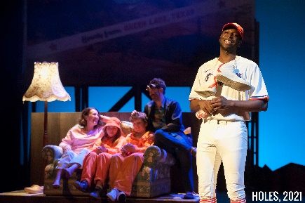
Theatre Royal Bury St Edmunds works to transform the lives of people in its local community through the power of the performing arts. We believe everyone, at all stages of their lives, regardless of background or personal circumstance, should have equal opportunity to engage in extraordinary cultural experiences.
Theatre Royal is a vibrant 200-year-old theatre located in the beautiful Suffolk town of Bury St Edmunds. First built in 1819, it was restored to its original regency design in 2007 and as a Grade 1 listed building, is the only theatre in the National Trust portfolio and considered to be one of the cultural sector’s ‘crown jewels’. As the last working Regency playhouse in the country, it offers visitors a unique and unforgettable theatrical experience.
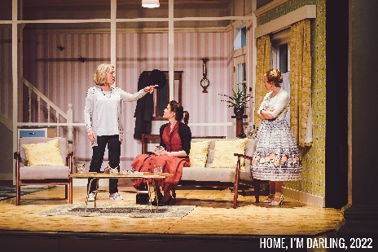
A major cultural and social asset and a key part of West Suffolk’s culture, heritage and tourism offer, we serve a population of 370,000. We are the only theatre in West Suffolk that both receives and produces high quality theatre, reaching 80,000 audience members each year. We pride ourselves on the quality and innovation of our in-house productions, with recent successes including: A Christmas Carol, Home, I’m Darling, and The Secret Garden. Our eclectic programme is carefully curated to ensure we have something for everyone, whether it’s cutting-edge contemporary theatre, traditional drama, dance, comedy, music spanning genres from classical to pop, or award-winning productions for children and young people. Over 20,000 people attend our renowned annual family pantomime each year.
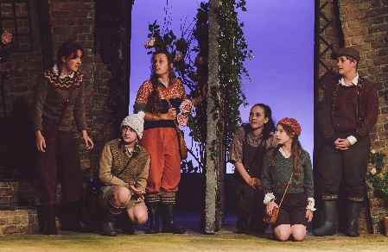
We pride ourselves on putting our community at the heart of everything we do. Our performing arts programme is augmented by a wide reaching & diverse Creative Learning offer which engages targeted community groups through bespoke partnerships. Our ambition is to further embed the voice of our community within all aspects of our offer, ensuring that our cultural & education programmes are designed with, by and for the people of West Suffolk.

The theatre employs a paid staff of 25 alongside a wider team of casual staff and supported by a dedicated team of approximately 140 volunteers. It is overseen by a highly skilled non-executive board of trustees. There is a Patron's Scheme and a thriving Friends scheme numbering over 600 members. The theatre receives core funding from West Suffolk Council and Suffolk County Council and also enjoys strong support from the local business community.

Vision + Mission
Our vision is to bring the Theatre Royal into the heart of our residents. Our mission is to shape, produce and showcase high quality, diverse theatre and participation activities that reach all corners of our community.

Values

Expansive: we work beyond the walls of our 19th century building
Inclusive: we are open to all, both on and off stage
Transformative: we transform the lives of our community through work that is unexpected, high quality, entertaining and thought provoking
Collaborative: we work in partnership, learn from others and share the knowledge and expertise we have
Resilient: we are steadfast in our approach to strong governance, operational leadership and financial acumen

